Group _____________ Name _________ No red!

Tasks on Expressing an Opinion (4 tasks)

Task 1
Complete the adjective clause in each sentence.
Step 1 Write who or which in the space in each sentence. (Do not use that in this exercise.)
Step 2 Highlight the noun that the adjective clause gives more information about.
Step 3 Highlight the verb in the adjective clause.

Arranged Marriages
- In arranged marriages, which arecommon in many countries, someone else chooses your marriage partner.
- Sometimes the parents, _____ know their child better than anyone, choose.
- Sometimes the parents hire a matchmaker, _____ charges a fee to find a suitable person.
- The two young people are probably very nervous at their first meeting, _____ usually takes place in the bride’s home.
- In some cultures, a young man or woman _____ doesn’t like the parents’ or matchmaker’s choice may say “no.”
- Marrying for love, ______ is the custom in most Western cultures, does not guarantee happiness.
- The divorce rate among couples _____ marry for love is very high.
- People _____ listened only to their hearts sometimes wish they had listened to their heads.

Task 2
Punctuate the following sentences. Add quotation marks, commas, capital letters, periods, and question marks. One sentence requires a comma but does not require quotation marks or capital letters.

- Before I came to the United States, my parents said to me don’t get sick while you are there.
- Before I came to the United States, my parents said to me,” Don’t get sick while you are there.”
- Why not I asked
- Medical care in the United States is too expensive they answered
- According to a little book about healthcare in the United States a two hour visit to the emergency room can cost more than $3,000 (not the exact words)
- I asked what happens if I can't pay
- I don’t know my father replied but I think you should find out
- According to the booklet the school will provide medical insurance while you are a student (exact words)
- My advisor said it doesn’t cover everything, so you might want to buy additional insurance from a private company

Task 3
Сomplete the outline
Step 1 On the first line, write an opinion topic sentence.
Step 2 Think of two or three reasons for your opinion and write them on the appropriate lines.
Step 3 Think of possible supporting details for each reason, and write them on the appropriate lines.
Step 4 Write a concluding sentence on the appropriate line.
Use the Example
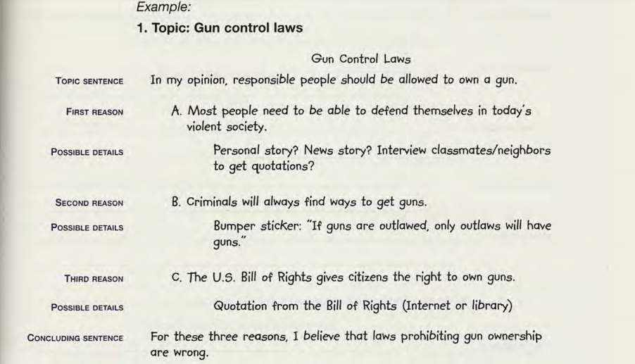

Topic: Using cell phones in public places

Using cell phones in public places

Topic sentence
A.First reason
Possible details

B.Second reason
Possible details

C.Third reason
Possible details

Concluding sentence

Task 4
Write an essay Using cell phones in public places according to your outline.

